# ANKUSH JHA

# BT22CSH023 ASSIGNMENT - 4

#include <stdio.h> #include <stdlib.h>

struct Node {

int data;

struct Node* next; struct Node* prev;

};

void insertAtEnd(struct Node** head, int data) {

struct Node* newNode = (struct Node*)malloc(sizeof(struct Node)); newNode->data = data;

newNode->next = NULL; newNode->prev = NULL;

if (*head == NULL) {

*head = newNode;

} else {

struct Node* current = *head; while (current->next != NULL) {

current = current->next;

}

current->next = newNode; newNode->prev = current;

}

}

struct Node* addNumbers(struct Node* num1, struct Node* num2) { struct Node* result = NULL;

int carry = 0;

while (num1 != NULL || num2 != NULL || carry != 0) { int sum = carry;

if (num1 != NULL) { sum += num1->data; num1 = num1->next;

}

if (num2 != NULL) { sum += num2->data; num2 = num2->next;

}

carry = sum / 10; sum %= 10;

insertAtEnd(&result, sum);

}

return result;

}

struct Node* reverseList(struct Node* head) {

struct Node* current = head; struct Node* temp = NULL;

while (current != NULL) { temp = current->prev;

current->prev = current->next; current->next = temp;

current = current->prev;

}

if (temp != NULL) { head = temp->prev;

}

return head;

}

void printList(struct Node* head) {

while (head != NULL) { printf("%d ", head->data); head = head->next;

}

printf("\n");

}

int main() {

// Input numbers

unsigned long long int num1 = 12365478; unsigned long long int num2 = 12685745;

struct Node* list1 = NULL;

struct Node* list2 = NULL;

while (num1 > 0) { insertAtEnd(&list1, num1 % 10); num1 /= 10;

}

while (num2 > 0) { insertAtEnd(&list2, num2 % 10); num2 /= 10;

}

list1 = reverseList(list1);

list2 = reverseList(list2);

struct Node* result = addNumbers(list1, list2);

result = reverseList(result);

printf("Sum: "); printList(result);

free(list1); free(list2); free(result);

return 0;

}

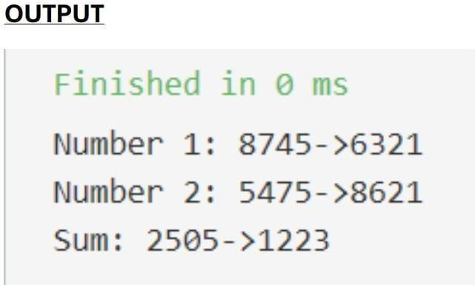

# TIME COMPLEXITY

1. CREATING LINKED LIST - O(N)

# ADDING NUMBERS - O(N)

1. REVERSING LINKED LIST - O(N)

# SPACE COMPLEXITY

1. WE USE N LISTS FOR N DIGITS HENCE SPACE COMPLEXITY - O(N)

# N = NUMBER OF DIGITS